Create an FTP-based YUM/DNF repository on RHEL 8

In Disconnected Environment

**Prerequisites**

You will need to set up two machines with Red Hat Enterprise Linux 8 systems, one local repo server, and one client machine that will use the local repository from the local server. For example:

Local Repository Server: RHEL 8 [10.0.0.10]

Local Client Machine: RHEL 8 [10.0.0.11]

RHEL 8 installation DVD

vsftpd FTP server

## Create your repository

Creating your repository involves a number of steps.

### Step 1: Mount the Red Hat Enterprise Linux 8 media

First, mount the local media (the DVD, USB stick, etc.) that contains Red Hat Enterprise Linux 8. Use the installation DVD:



**Step 2: Create a local YUM repository from the mounted media**

Move the existing repo files located in /etc/yum.repos.d:



From this point, it is better if you continue as the root user. Switch to superuser with su command.

Next, create a directory for the repo:



Use this directory with vsftpd for serving files over the LAN.

Create the new local repository’s configuration file local-dvdrom.repo under the /etc/yum.repos.d directory:



### Step 3: Copy media content to the local directory

Copy the ISO files locally under the /local_repo directory:

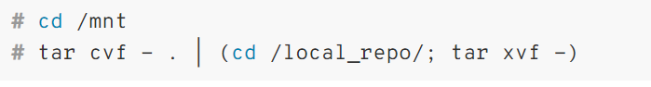

Wait until the files are copied, then verify the files were copied using:

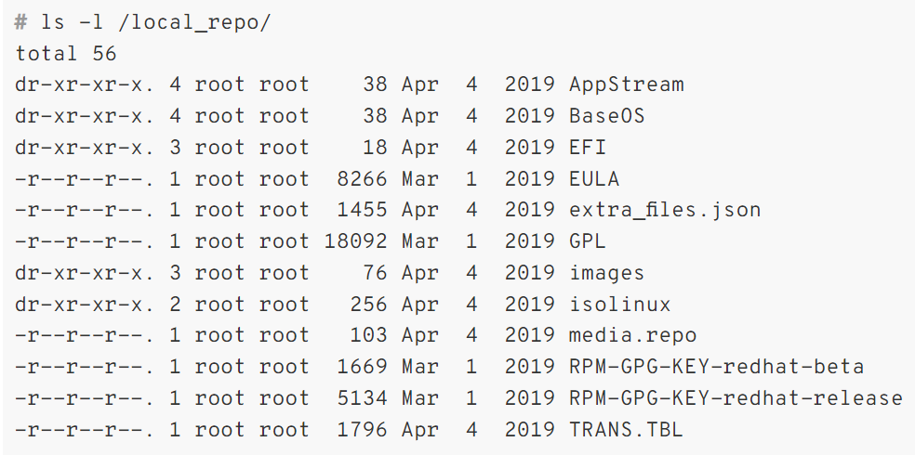

Step 4: Configure the local YUM/DNF repository



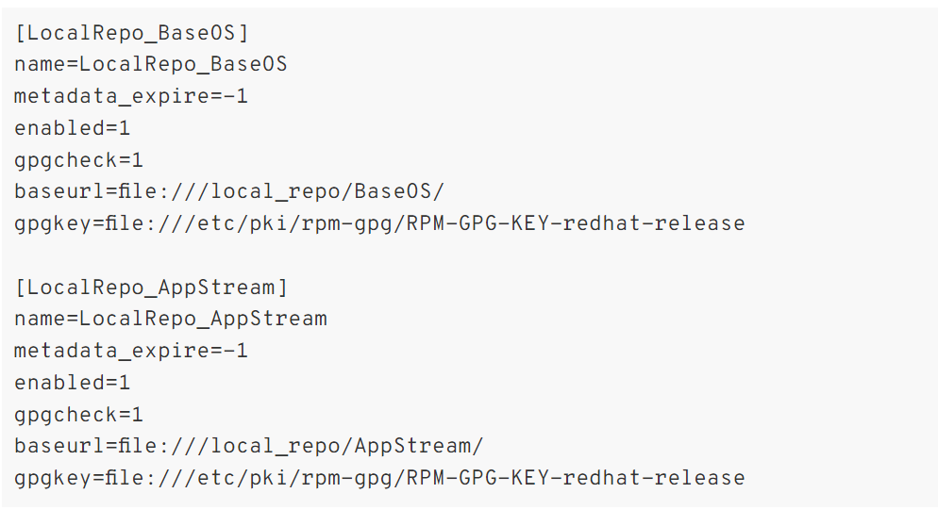

Install the required packages for creating, configuring and managing the local repository

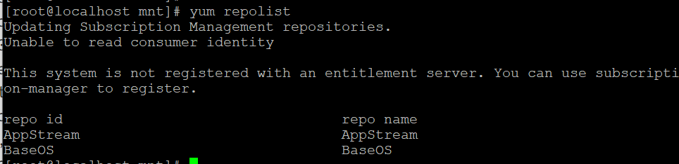

# yum install createrepo yum-utils

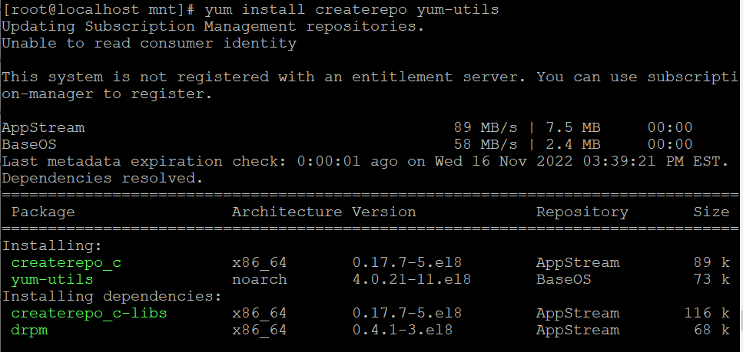

Finally, run the createrepo command:

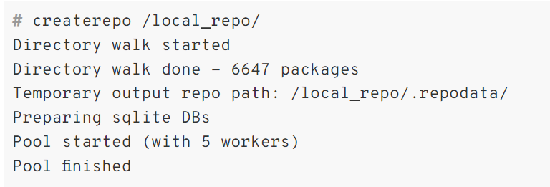

Step 5: Test and verify your local repository

In this step, you clean up the temporary repository files and verify that the local repository is enabled:

# yum clean all

# yum repolist

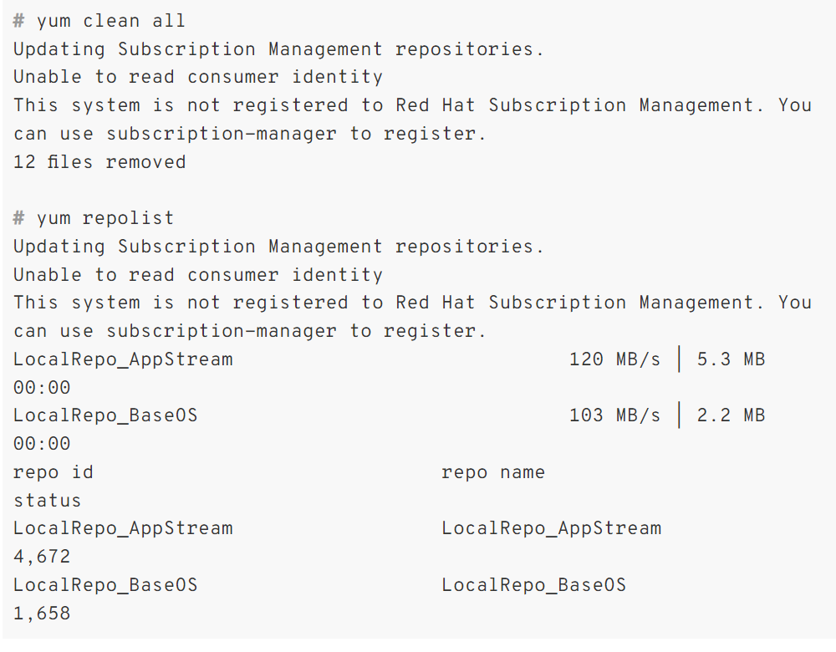

Verify that the local repository was created:

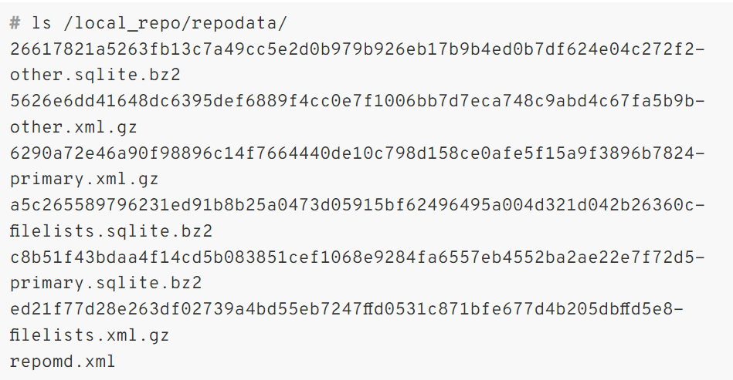

You can see that the local repository generated files, so everything is ok at this point.

If you read the above command output carefully, you are getting the warning message, This system is not registered to Red Hat Subscription Management. You can use subscription-manager to register. If you want to suppress or prevent this message while running the dnf or yum command then edit the file /etc/yum/pluginconf.d/subscription-manager.conf



and change the parameter enabled=1 to enabled=0:

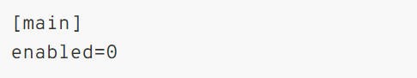

**Set up your FTP server**

**Step 5: Test and verify your local repository**

Verify that the local repository was created:

As I mentioned before, this article covers setting up your own repository using an FTP server (in this case, vsftpd). I'll walk you through installing and configuring vsftpd to serve your repo.

### Install vsftpd

To set up your FTP server to handle your rep, first install vsftpd:

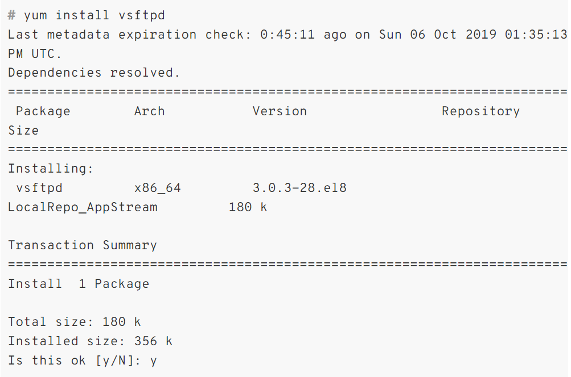

**Configure vsftpd to auto-start at boot**

Once vsftpd is installed, start and enable the service to auto-start at boot and verify its status using the following commands

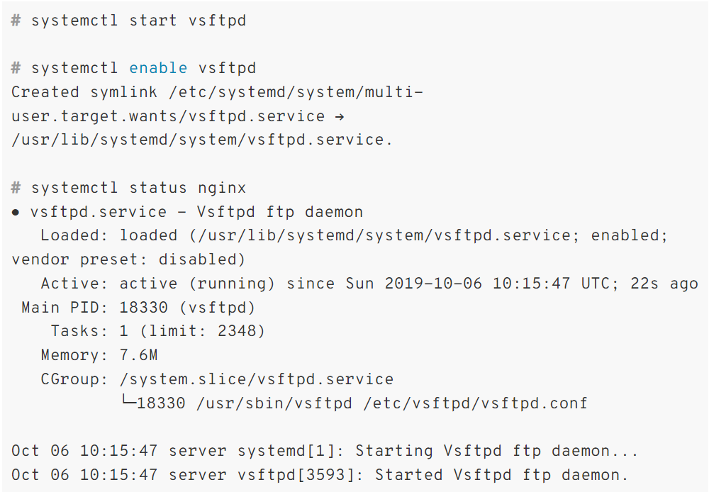

**Configure the firewall**

Next, you must configure the firewall so that vsftpd can be reached:

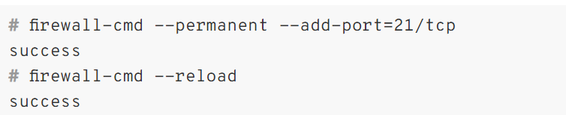

**Configure vsftpd**

To configure vsftpd, open the configuration file:



When opened, change the following:

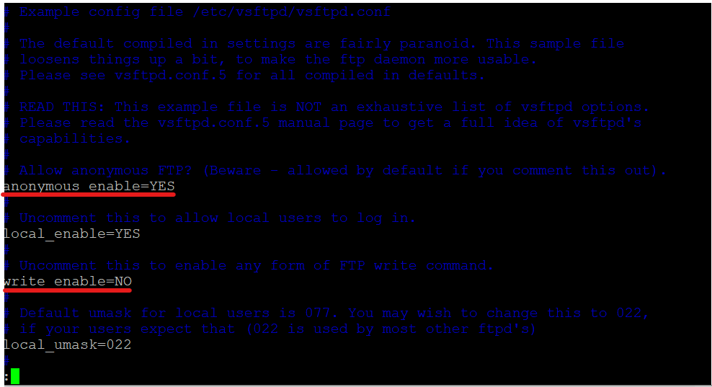

Add the following line anywhere in the configuration file:



**Test and clean up**

Finally, restart and test the vsftpd service:

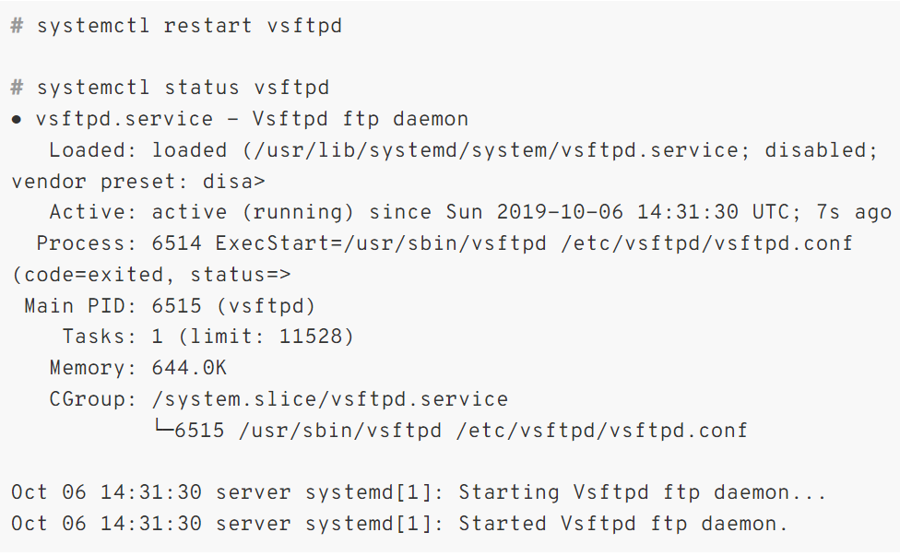

**Change permissions and set SELinux**

Continue the security configuration by changing the permissions on the local_repo directory and configuring SELinux. To change the permissions:



Then, check if SELinux is enforcing:

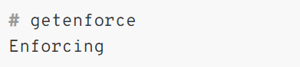

If it is Enforcing, type:



**In Both Systems Open The Network Configuration File And Comment Some Of the Lines Inside**

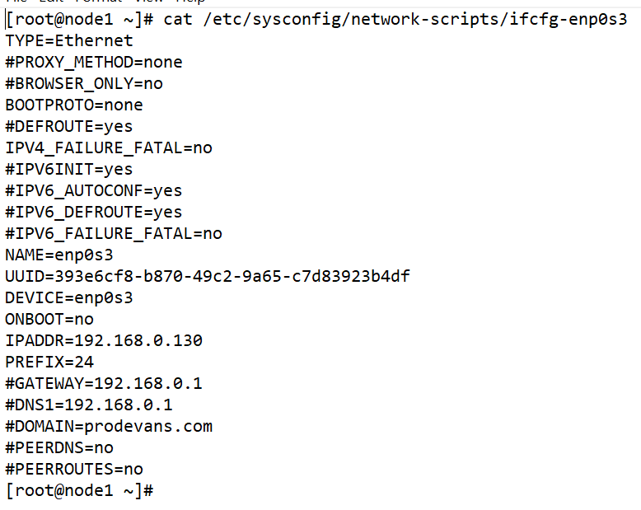

**Set up the client**

Now, to configure the Red Hat Enterprise Linux 8 client machine’s repository.

**Add the repos**

On the client machine, add the local repos from the server to the client’s YUM configuration:



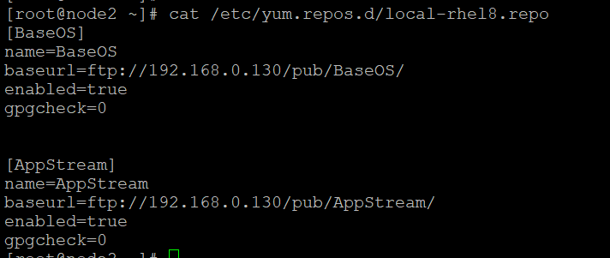

**Reference Link**

**1).** [Create an FTP-based YUM/DNF repository on Red Hat Enterprise Linux 8 | Enable Sysadmin](https://www.redhat.com/sysadmin/ftp-yum-dnf-repository)